**“Does a certification take you farther than a bachelor's degree in the Technology field?”**

***CTEC 128-402***

*Ibrahima Balde*

*Micah Neal*

*Nathaniel Nelson*

**Introduction**

The field of technology is huge and endless in opportunity. Traditionally, the standard form of getting your foot into the door of this career is through seeking higher education and obtaining a bachelor's degree at an accredited university. However, due to the course of everlasting change in society, new ways of starting your career path in technology have been maneuvered and notably used. Namely being to receive accredited certifications in the specified field of technology you are trying to enter (CompTIA, Security+, etc.). The goal of this data project will be to assess the difference between certification and bachelor’s degree recipients, and whether certifications have become a more effective way to be successful in the technology industry.

Our team of data scientists will be analyzing the connection between these two options to take part in technology and whether one is more useful than the other in today's time. We will be completing this by using data from the U.S. Bureau of Labor Statistics that allows us to look at the statistics of full-time employees in technology who have just bachelor’s degrees compared to just certifications and their specific advancement levels to really determine if one is more effective than the other.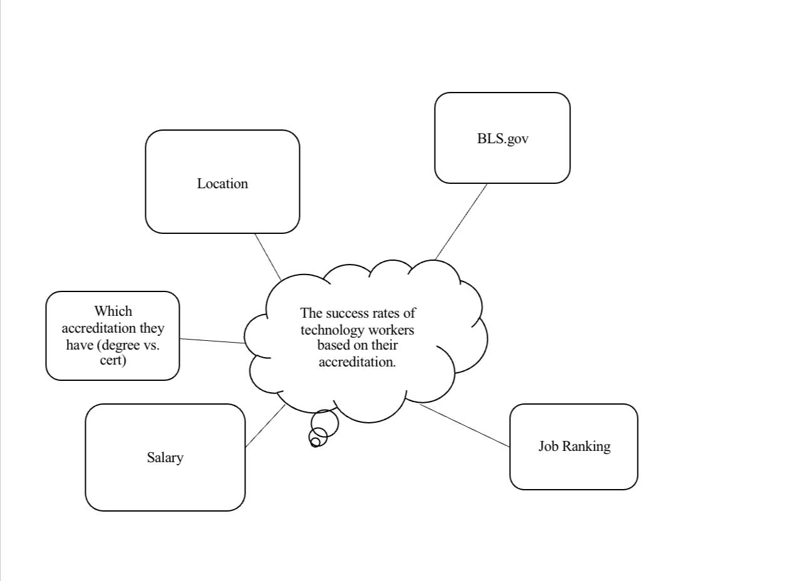

**Figure 1:** Concept Idea Map

1. Intro

* Topic/Research Question-Does a certification take you farther than a bachelor's degree in the Technology field?
* Project Objectives/Goals- Which field of technology is the focus?
* What is the success of the full-time workers being determined by?
* Which job in the technology field offers the most pay?
* What is the relationship between bachelors degree holders and full time-workers in technology?
* Is there such a thing as being overqualified?

-We chose this topic because as CTEC majors, we thought it would be interesting to figure out if the degree we are all going for is more beneficial than another ulterior route we all could have decided to take. Overall, did we make the right decision by coming to college?

1. Data Science Pipeline Steps

* Data Ingestion

            Name of data source and who collects it - American Community Survey (ACS) and (BLS)

Overview- The American Community Survey’s main purpose is to inform local administrators, leaders, businesses of the changes in our community. The Bureau of Labor Statistics (BLS) is responsible for collecting, processing, analyzing, statistical data pertaining labor, economics, and also measures the income level families need to maintain a successful quality of life.

Years of Data Available- 1939/83 years (BLS) and 5 years (ACS)

What is the instance? - The instance of ACS was to find how many people have tech jobs in MD/DC. The instance of using BLS was to see how many individuals have a job in tech and whether a degree is required, or certification is required.

Specific year of data being used? - 2018 (BLS) and 2021 (ACS)

* Data Wrangling

Final features selected for the project? - The features selected from ACS for the most precise data collection in our project was educational attainment (SCHL), SEX, race (RAC1P), standard occupational classification (SOCP), and (ST) for state. From BLS, the features we selected that fit best to gauge an accurate finding was Occupation: Total, with a certification or license. We also included from BLS, which jobs required certification/license.

If the decision was made to only use a portion of the data, describe it? - When figuring out which portion of data to be finally selected, we decided to use ACS for people with a degree and are employed at a tech job. Then, we used BLS for people who were employed with tech jobs and had no degree with a certificate in the respective field.

For the final analytic data set, what is the number of instances and features? - For the final analytic data set, the number of instances from ACS was 12,994 and the number of features was 5. The total number of instances for BLS is 37,556. The total feature for BLS was 1 feature due to the certification/license being in one category. In total are instances equal to about 51 thousand instances we worked with to find our data. After full breakdown of data the total instances we used while researching and solving data question was 3,373.

Discuss any featuring engineering that was done- The feature engineering that was performed was mostly from ACS. We had to manipulate the standard occupational classification (SOCP) field to only occupations that involved tech jobs. This helped us distinguish the accurate number of persons employed with a technology field related job.

Discuss all data errors and issues. How were they resolved? - The data error we encountered was finding out how many people had a tech job with no degree and certification. This was a hard task because ACS only had people with no degree at all and didn’t show if they had certs or not in the tech field.

* EDA + Visualizations

Reiterate the project research/questions

For the Technology field, does either a certification or a bachelor’s degree take you farther in it?

-What fields of technology are the focus? The fields of technology are computer and mathematical occupations which are jobs that involve examining large amounts of data for software processes.

-What is the salary /competitive rank of full-time workers being determined by? The salary/competitive rank of full-time workers being determined is anywhere from 100,000 to 160,000 after bonuses per year.

-Which job in the Tech field offers the highest paying job/position? The highest paying tech job/position is either an Information Systems Security Manager or Data Scientist. The pay for an experienced systems security manager makes about $153,677 and a Data Scientist is 150,000 which is very close.

-How much relation does having a bachelor’s and being a full-time worker in Tech have? It is in your best interest to attain both a bachelor’s degree and work full time due to the number of benefits you have at hand. This may include high paying bonuses, manager positions, and easier access to promotions.

-Can someone be overqualified for a position? Regarding certifications and any level of degree, specifically bachelor’s degree, in the tech field there is really no overqualification. Having a degree with a certification will expose you to higher paying jobs/positions.

Describe EDA findings

1. Within our findings, we have found that a certification can take you farther in the Technology field because in the data we found, we saw that there was a much larger number of people who had certifications vs those that just had their bachelor’s degree.
2. For the field of Technology that is the focus, we ended up not having a focus in that regard. But my group did end up putting focus in the couple of fields we could find in our data that had relation to STEM.
3. For the salary/competitive ranks, we were unable to properly find the answer to our question with the data that we were using. But we believe that the accolades that one gains(Degree, certifications, etc) can help one achieve a potentially higher salary for a position.
4. Using that data that we have found within the datasets; w
5. Having a bachelor’s degree isn’t as emphasized as a need as before, but a lot of positions that are full-time in the technology field involves having a bachelor’s degree

           Include visualizations

Data Insights

           What did you learn from the data?

From the data I learned that have a degree is the most beneficial to maneuver in the technology field. Having both a degree and certificate is the most ideal

           What are some actionable insights based on what you have learned from the data? From the data collected, actionable insights we learned that it is better to attain a degree when entering the tech field due to the salary pay difference.

Proposed Data Product

            Describe a potential data product that could be produced with data?

The potential data product that we would like to propose is a career handguide that revolves around the field of Technology using the data that we had found.

Project Challenges

            Any problems or pitfalls? Not being able to find an answer to all our objective questions based upon the data we found.

            What would you do differently? Differently we can either choose a better topic that has more data available at hand to work with and manipulate to come to more of an effective result or conclusion of the data we collected.

Future Projects

            If you had more time, what would you do? If we had more time, I would create an informative website detailing the ins and outs of the tech field and how to thrive in it.

If we had more time, we would make a website or app giving ins and outs of ways to attain a high paying tech job. Many people can’t afford college and getting a certification would be their best option. Although having a degree would be the best option, saving money and not being in debt due to tuition fees would be even better.

Bureau, U. S. C. (2022, February 24). Educational attainment in the United States: 2021. Census.gov. Retrieved December 12, 2022, from https://www.census.gov/data/tables/2021/demo/educational-attainment/cps-detailed-tables.html ​

U.S. Bureau of Labor Statistics. (n.d.). Professional Certifications and occupational licenses: Evidence from the Current Population Survey : Monthly labor review. U.S. Bureau of Labor Statistics. Retrieved December 12, 2022, from https://www.bls.gov/opub/mlr/2019/article/professional-certifications-and-occupational-licenses.htm ​

U.S. Bureau of Labor Statistics. (2022, September 8). Computer and Information Research Scientists : Occupational outlook handbook. U.S. Bureau of Labor Statistics. Retrieved December 12, 2022, from https://www.bls.gov/ooh/computer-and-information-technology/computer-and-information-research-scientists.htm ​

U.S. Bureau of Labor Statistics. (n.d.). Education pays, 2020 : Career outlook. U.S. Bureau of Labor Statistics. Retrieved December 12, 2022, from https://www.bls.gov/careeroutlook/2021/data-on-display/education-pays.htm ​